

**Touchstones**

***Netcards***

**Spirituality Netcards with Text**

Being HRJ

Breathe HRJ

Cat HRJ

Crying HRJ

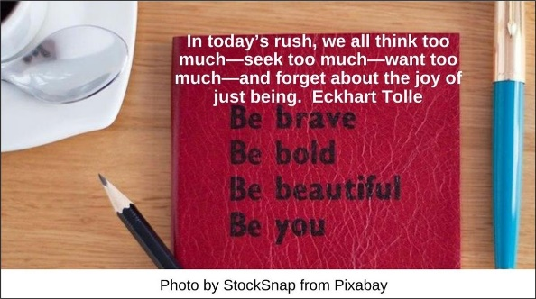

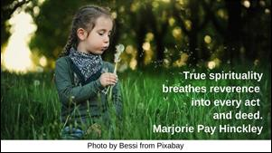

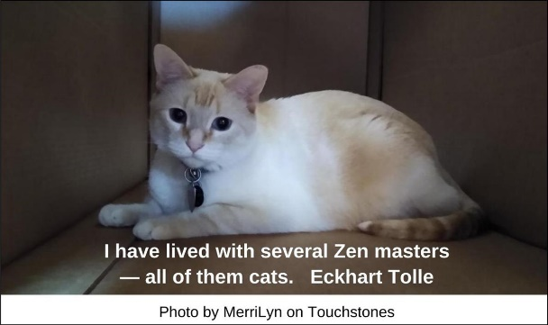

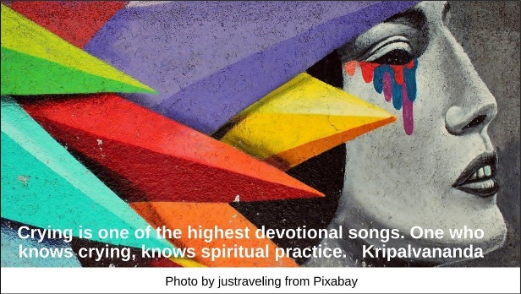

Doing HRJ

Everyday HRJ

Eyes HRJ

Happiness HRJ



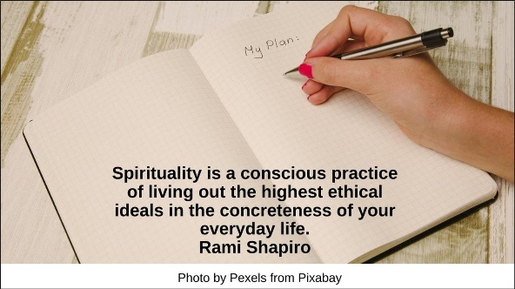

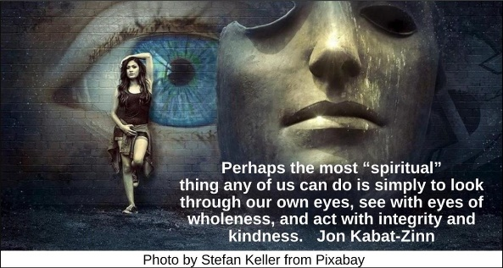



Harmony HRJ

Hate HRJ

Heart HRJ

Joy HRJ

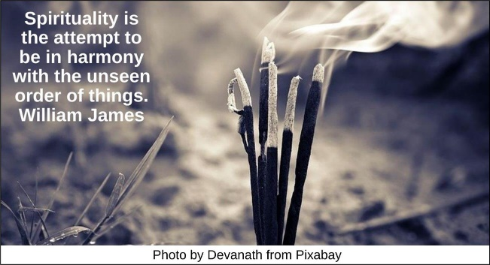



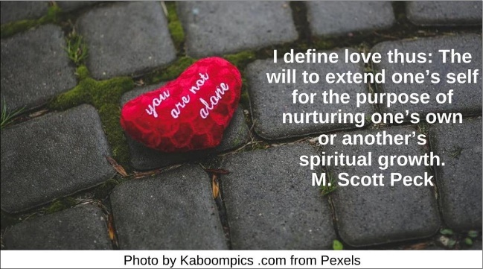

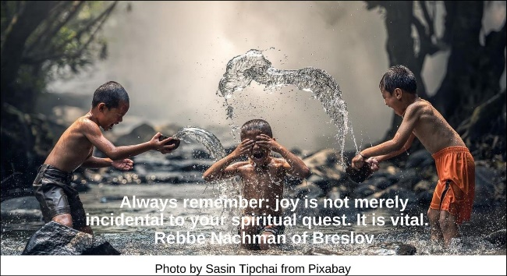

Justice HRJ

Laughter HRJ

Listening HRJ

Little Stream HRJ





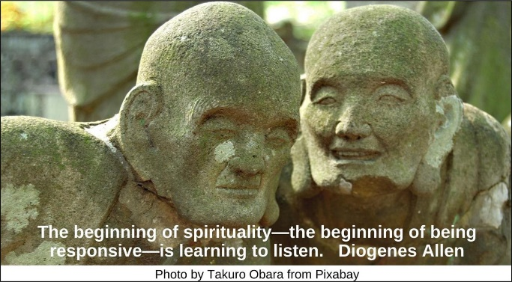

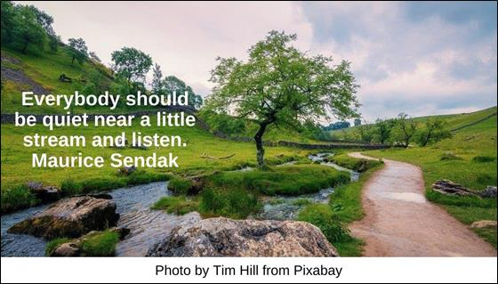

Mindfulness HRJ

Mysterious HRJ

Nighttime Sky HRJ

No Meanness HRJ

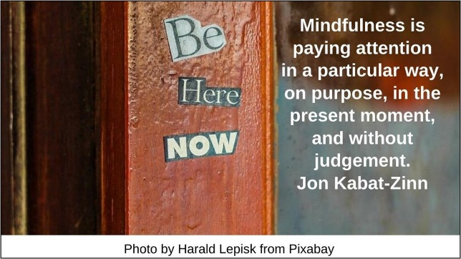

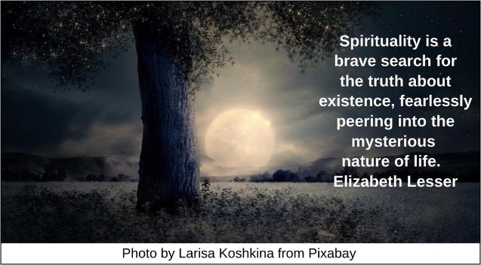

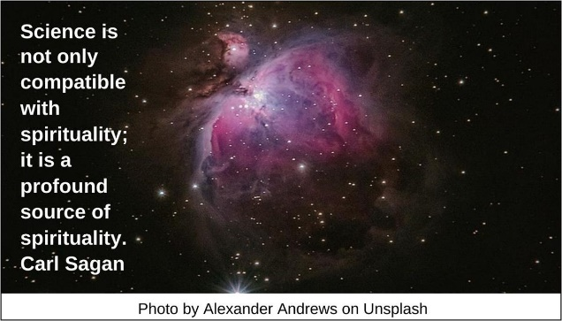

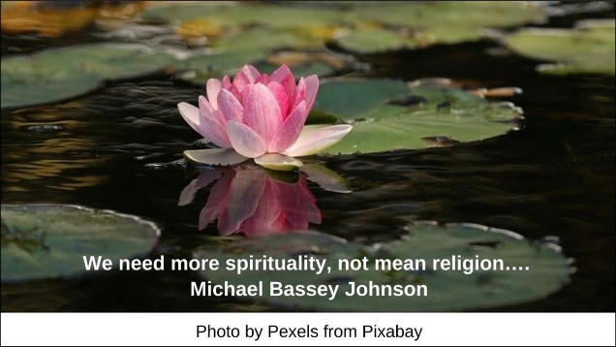

Opened HRJ

Peak Experiences HRJ

Peeling Potatoes HRJ

Searching HRJ

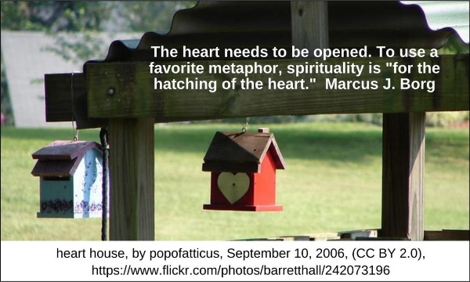

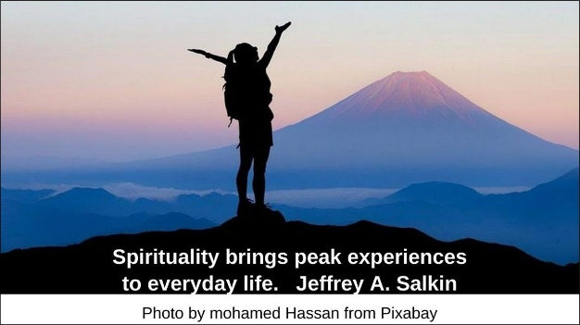

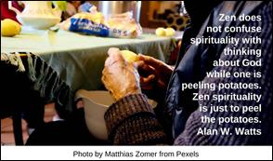

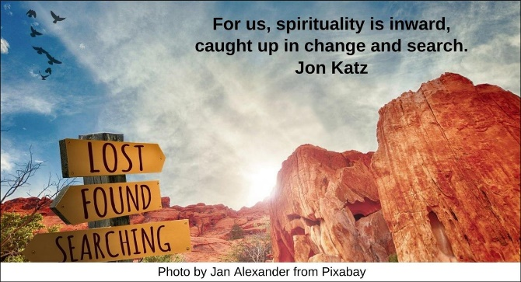

Shadow HRJ

Sleeping HRJ

Social Action HRJ

Spiritual HRJ

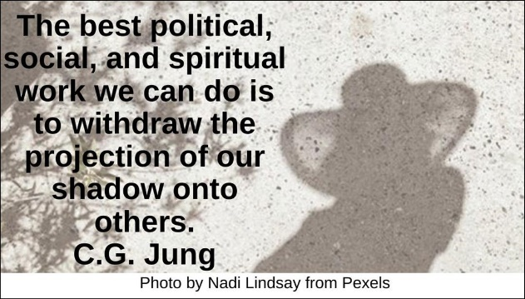

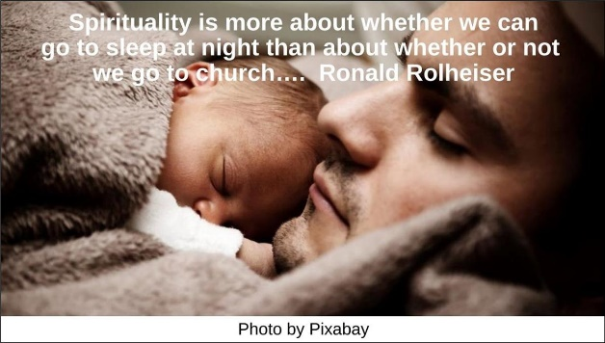

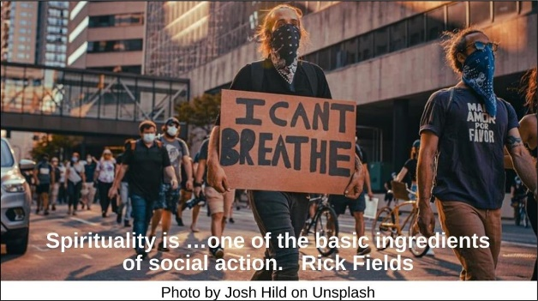



Thanks HRJ

Thanksgiving HRJ

Travel HRJ

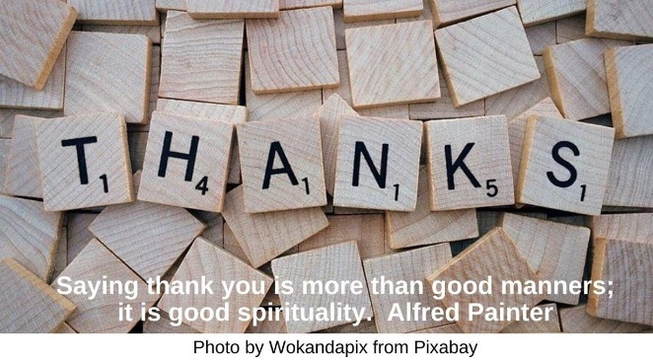

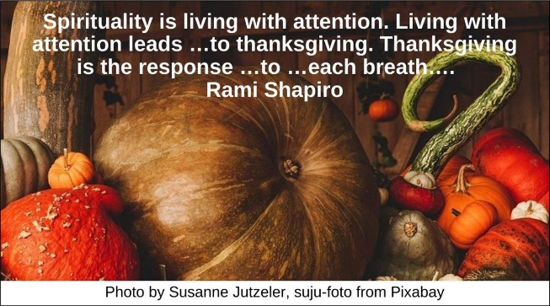

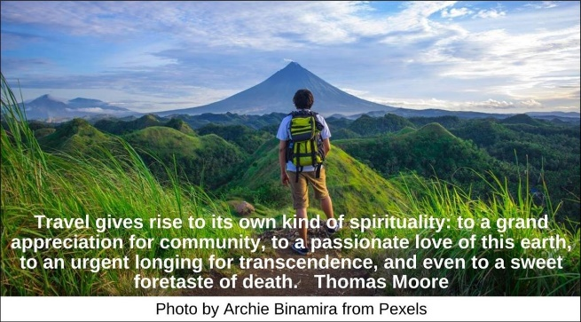

**Text of Quotes**

Being HRJ

In today’s rush, we all think too much—seek too much—want too much—and forget about the joy of just being. Eckhart Tolle

Breathe

True spirituality breathes reverence into every act and deed. Marjorie Pay Hinckley

Cat HRJ

I have lived with several Zen masters—all of them cats. Eckhart Tolle

Crying HRJ

Crying is one of the highest devotional songs. One who knows crying, knows spiritual practice. Kripalvananda

Doing HRJ

It is not what to do, but how much love we put into the doing. Mother Theresa”

Everyday HRJ

Spirituality is a conscious practice of living out the highest ethical ideals in the concreteness of your everyday life. Rami Shapiro

Eyes HRJ

Perhaps the most “spiritual” thing any of us can do is simply to look through our own eyes, see with eyes of wholeness, and act with integrity and kindness. Jon Kabat-Zinn

Happiness HRJ

Happiness is the spiritual experience of living every minute with love, grace, and gratitude.” Denis Waitley

Harmony HRJ

Spirituality is the attempt to be in harmony with the unseen order of things. William James

Hate HRJ

...I want my spirituality to rid me of hate, not give me reason for it. Donald Miller

Heart HRJ

I define love thus: The will to extend one’s self for the purpose of nurturing one’s own or another’s spiritual growth. M. Scott Peck

Joy HRJ

Always remember: joy is not merely incidental to your spiritual quest. It is vital. Rebbe Nachman of Breslov

Justice HRJ

A spirituality of justice has a communal goal, a vision of harmony and health in relationships…. David W. Augsburger

Laughter HRJ

Rest and laughter are the most spiritual and subversive acts of all. Laugh, rest, slow down. Anne Lamott

Listening HRJ

The beginning of spirituality—the beginning of being responsive—is learning to listen. Diogenes Allen

Little Stream HRJ

Everybody should be quiet near a little stream and listen. Maurice Sendak

Mindfulness HRJ

Mindfulness is paying attention in a particular way, on purpose, in the present moment, and without judgement. Jon Kabat-Zinn

Mysterious HRJ

Spirituality is a brave search for the truth about existence, fearlessly peering into the mysterious nature of life. Elizabeth Lesser

Nighttime Sky HRJ

Science is not only compatible with spirituality; it is a profound source of spirituality. Carl Sagan

No Meanness HRJ

We need more spirituality, not mean religion…. Michael Bassey Johnson

Opened HRJ

The heart needs to be opened. To use a favorite metaphor, spirituality is "for the hatching of the heart." Marcus J. Borg

Peak Experiences HRJ

Spirituality brings peak experiences to everyday life. Jeffrey A. Salkin

Peeling Potatoes HRJ

Zen does not confuse spirituality with thinking about God while one is peeling potatoes. Zen spirituality is just to peel the potatoes. Alan W. Watts

Searching HRJ

For us, spirituality is inward, caught up in change and search. Jon Katz

Shadow HRJ

The best political, social, and spiritual work we can do is to withdraw the projection of our shadow onto others. C.G. Jung

Sleeping

Spirituality is more about whether we can go to sleep at night than about whether or not we go to church…. Ronald Rolheiser

Social Action HRJ

Spirituality is …one of the basic ingredients of social action. Rick Fields

Spiritual HRJ

We are not human beings having a spiritual experience. We are spiritual beings having a human experience. Pierre Teilhard de Chardin

Thanks

Saying thank you is more than good manners; it is good spirituality. Alfred Painter

Thanksgiving

Spirituality is living with attention. Living with attention leads …to thanksgiving. Thanksgiving is the response …to …each breath…. Rami Shapiro

Travel

Travel gives rise to its own kind of spirituality: to a grand appreciation for community, to a passionate love of this earth, to an urgent longing for transcendence, and even to a sweet foretaste of death. Thomas Moore